Test Case Plan
To complete the test case plan, use the prepared test steps below. Developers and peer testers should enter names/dates, mark each step yes or no, attach the tester screenshot, and record substantive findings in the Comments section.
Project: Moffat Bay Marina – Green Team
Alexander Baldree
Max Jankowski
Aftabur Rahman
Jordan Dardar
Course: CSD460
Description: Functional test plan for the About Us and Reservation Summary pages and associated backend code (4 tests total: 2 per page).
Date: 2026/09/06

TABLE OF CONTENTS
Test 1: Public Access and Content on the About Us Page.....................................2
Test 2: About Us Navigation and Linked Page Routing..........................................4
Test 3: Successful Reservation Summary Display After Creation…………….6
Test 4: Confirming a Pending Reservation from Summary Page ……………..8

Test 1 | Public Access and Content on the About Us Page
 | Test Objective: Verify that visitors can access the About Us page without logging in and that the page returns the intended Moffat Bay Marina information without server errors. | Developer: Alexander Baldree  Date tested: 2026/09/06 | Peer tester: Jordan Dardar  Date tested: 2026/09/08
Step | Action | Expected results | Developer pass/fail | Tester pass/fail + Screenshot
1 | Log out or start a private browser session. | No authenticated customer session is active. | Yes | Yes  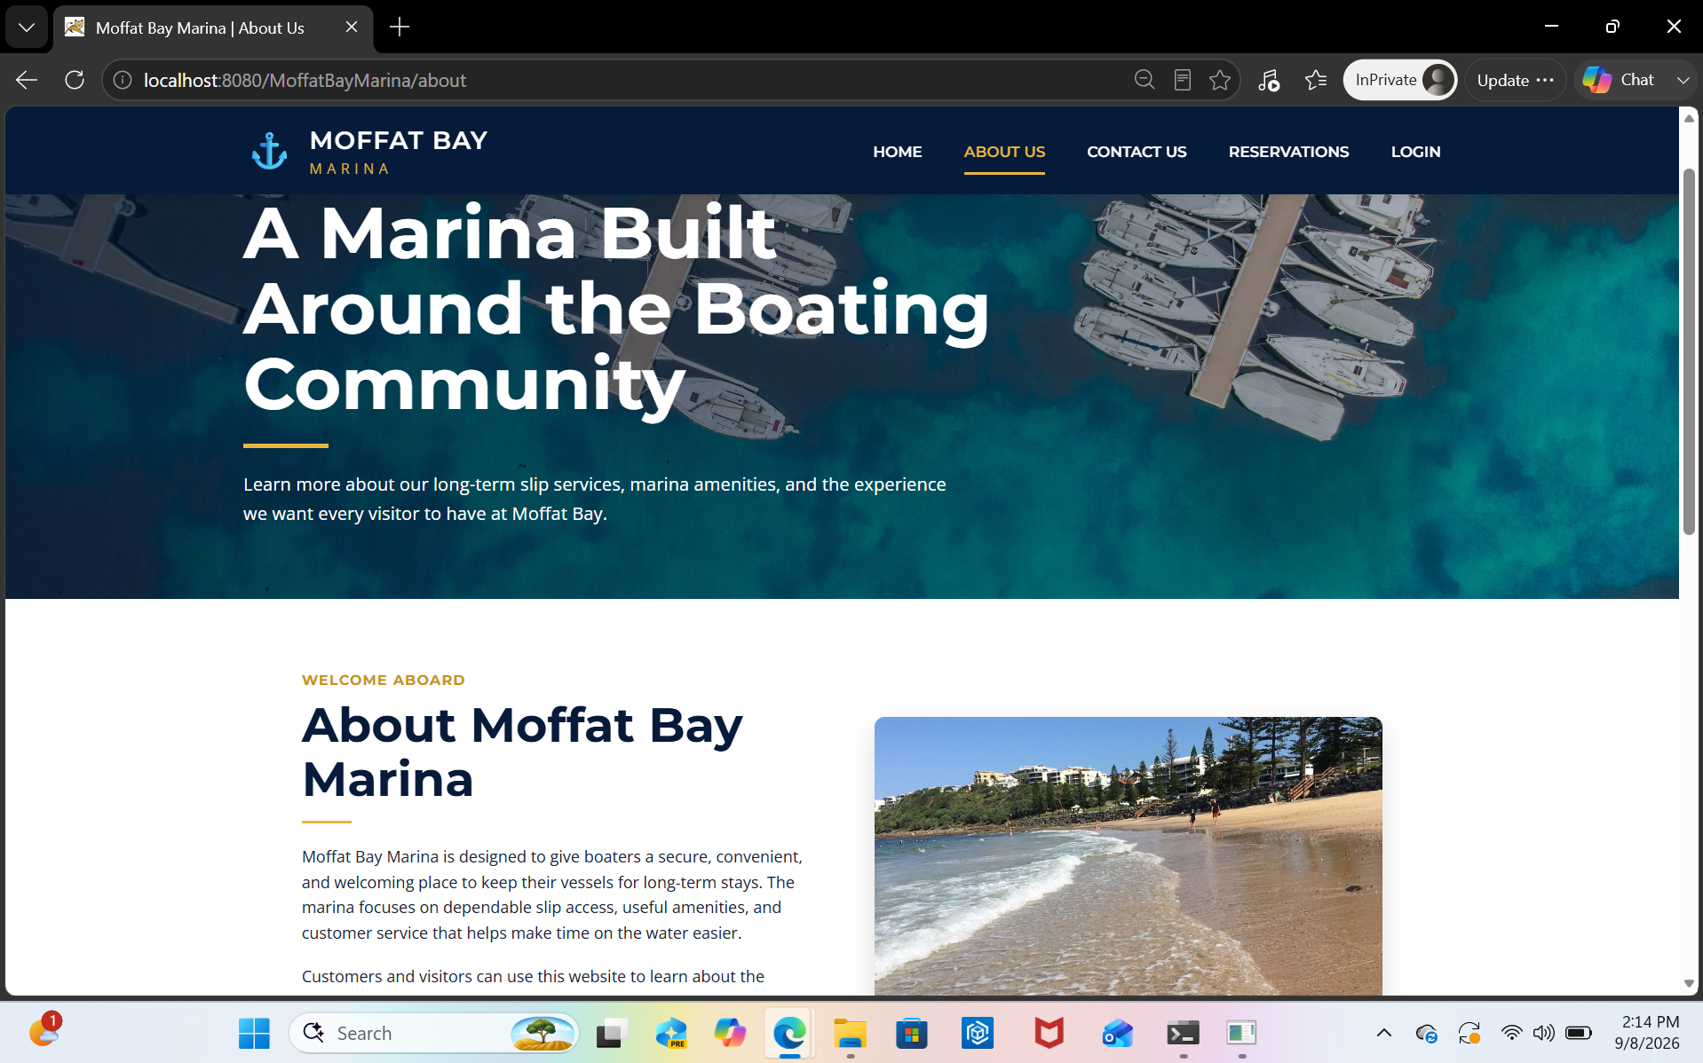
2 | From the landing page navigation, select About Us. | The About Us page opens without requiring login or registration. | Yes | Yes  
3 | Open the About Us page directly by its application URL. | The server returns the About Us page successfully with no 404/500 error or login redirect. | Yes | Yes  
4 | Review the main About Us content required by the project, including the marina description/information. | The expected Moffat Bay Marina information is present and readable. | Yes | Yes  
5 | Refresh the page and use the browser Back/Forward controls to return to About Us. | The page continues to load correctly and remains publicly accessible. | Yes | Yes  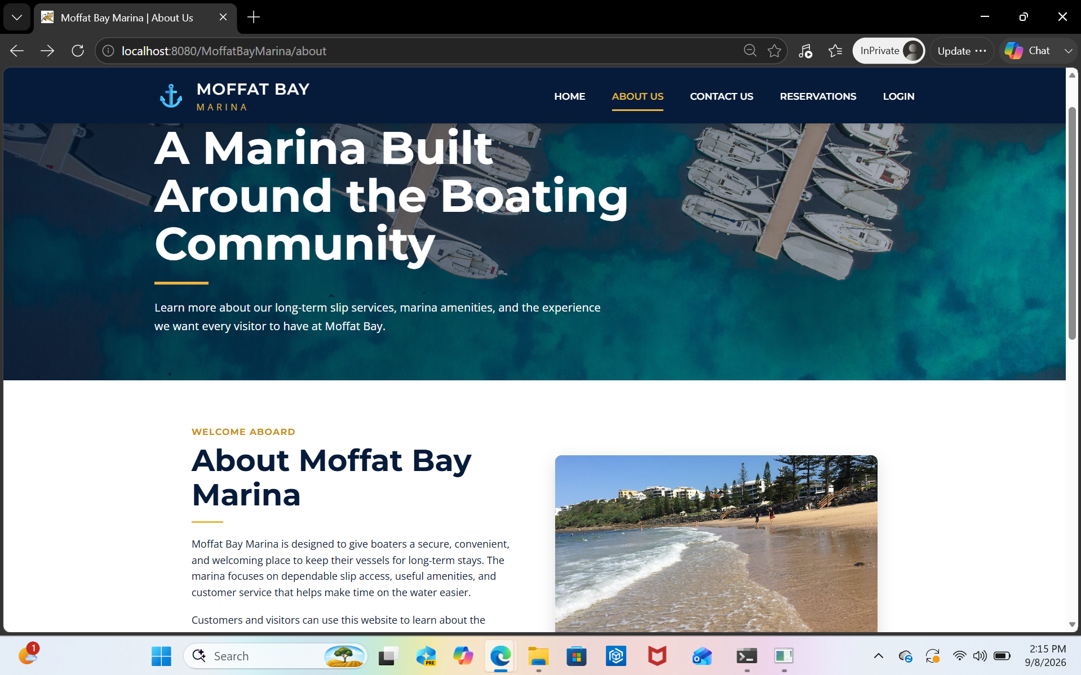
Comments | The About Us page loaded successfully in an InPrivate session without requiring authentication and was also reachable directly through the /about application route. The marina description and page content were readable, and refresh plus browser Back/Forward navigation continued to load the page correctly.

Test 2 | About Us Navigation and Linked Page Routing
 | Test Objective: Verify that the About Us page is correctly integrated into site navigation and its primary links route users to the intended pages without broken application paths. | Developer: Alexander Baldree  Date tested: 2026/09/06 | Peer tester: Jordan Dardar  Date tested: 2026/09/08
Step | Action | Expected results | Developer pass/fail | Tester pass/fail + Screenshot
1 | Open About Us from the main site navigation. | The About Us route/page loads and the common navigation is available. | Yes | Yes  
2 | Use the Home/Landing navigation link. | The user is routed to the landing page without a 404/500 error. | Yes | Yes  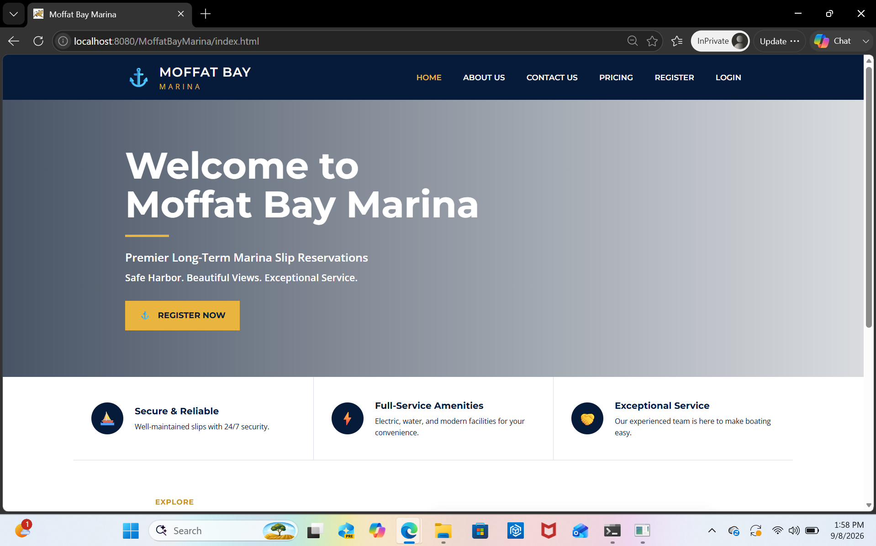
3 | Return to About Us and use the Contact navigation link. | The user is routed to the Contact page successfully. | Yes | Yes  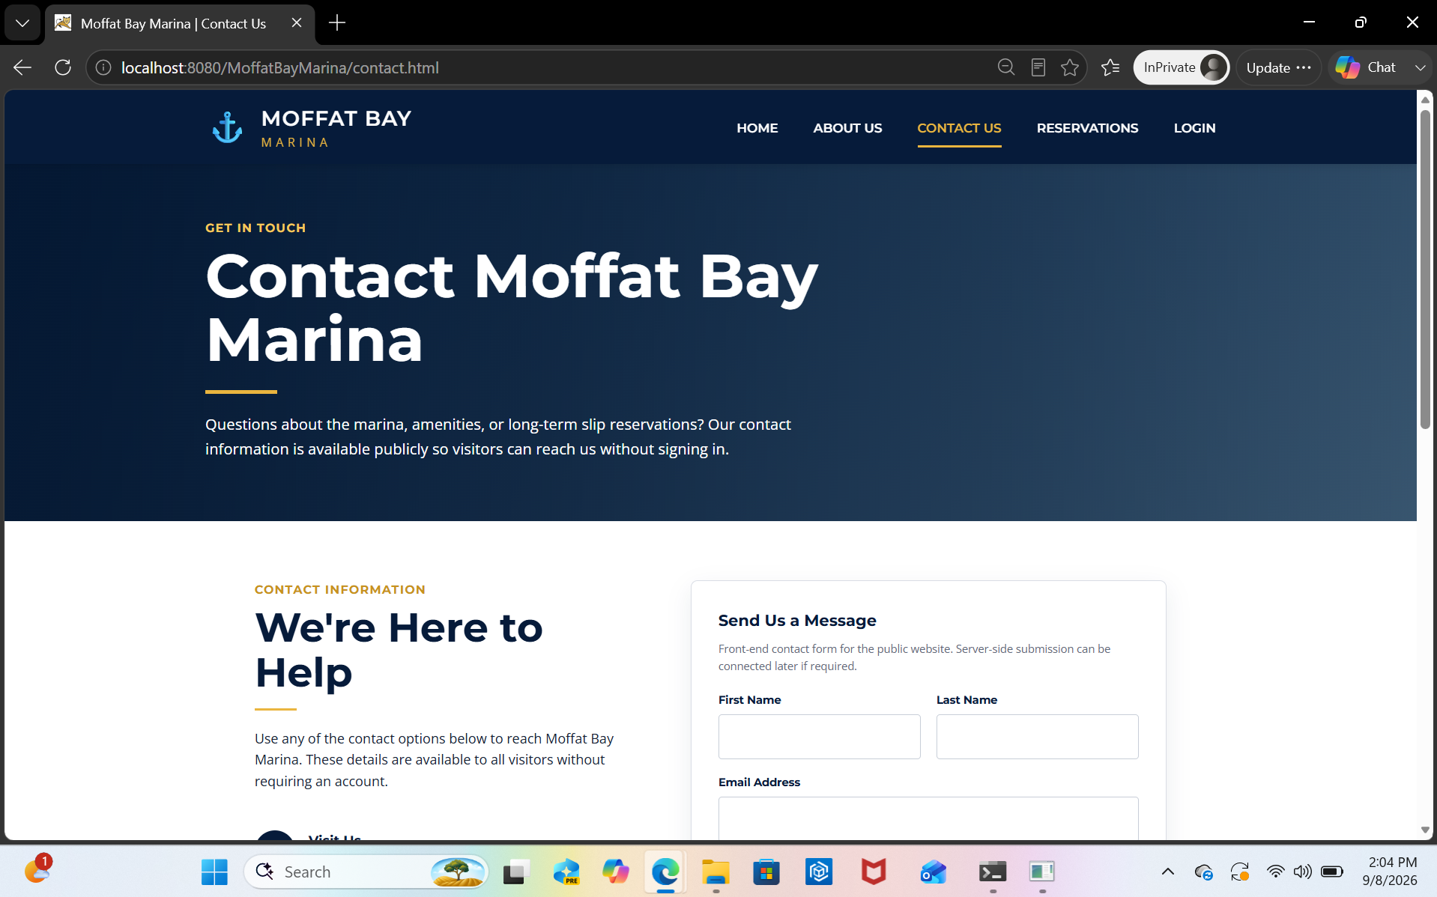
4 | Return to About Us and use the reservation-related navigation/action link. | The user reaches the intended reservation page, or is prompted to log in/register when authentication is required. | Yes | Yes  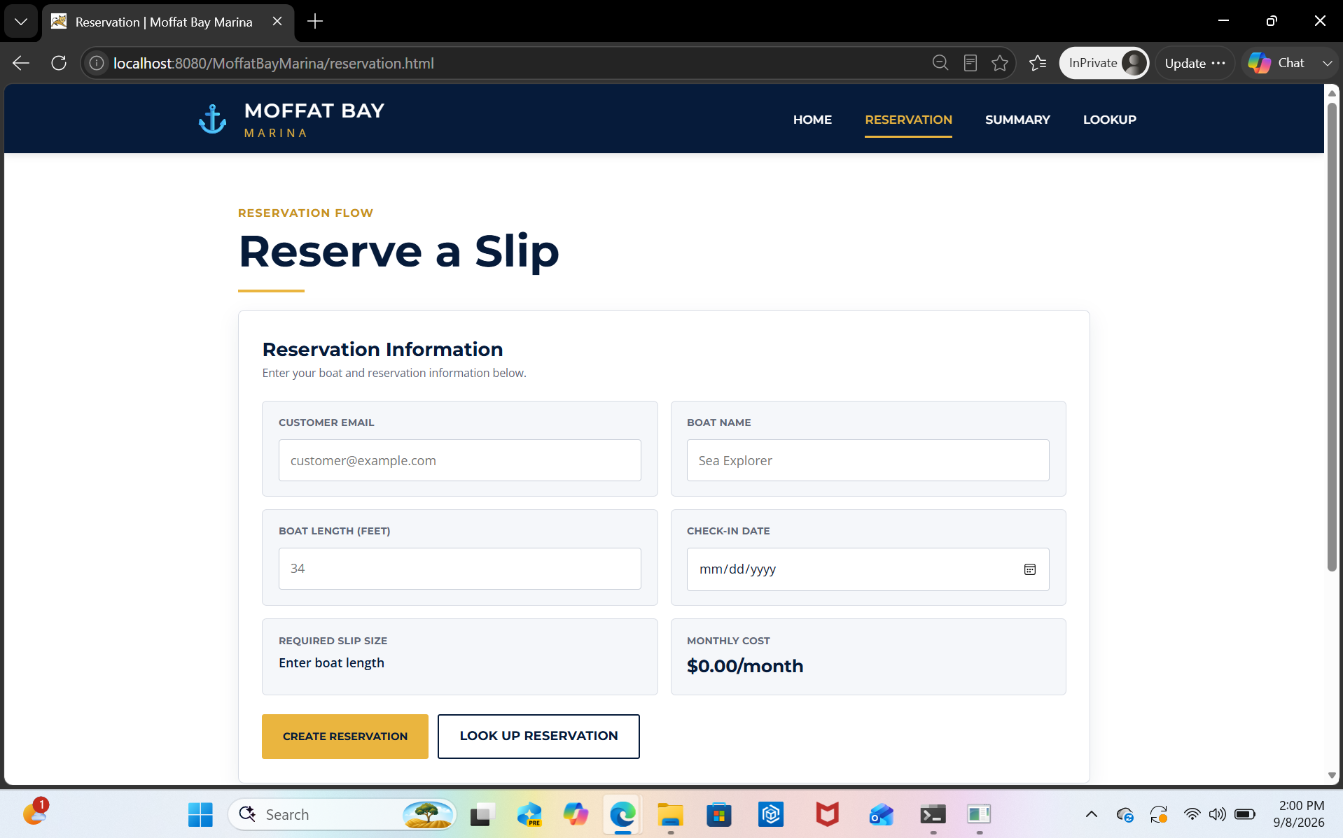
5 | Reload About Us and verify its linked CSS/images/site resources and navigation routes load without broken requests. | The page remains functional and no required linked resource or primary route returns an application error. | Yes | Yes  
Comments | The About Us page remained correctly integrated with the site navigation. Home, Contact Us, and Reservations routed to their intended pages without application errors, and the final reload showed the page styling and both About Us images loading correctly.

Test 3 | Successful Reservation Summary Display After Creation
 | Test Objective: Verifies that immediately after a customer successfully creates a reservation, reservation-summary.html accurately displays every detail of that reservation, including the correct monthly cost at the $10.50 per foot rate and the customer's electric service selection. | Developer: Aftabur Rahman  Date tested: <2026/09/12> | Peer tester: Max Jankowski  Date tested: <2026/09/12>
Step | Action | Expected results: | Developer pass/fail | Tester pass/fail  + Screenshot
1 | Log in and submit a new reservation on reservation.html for a boat that requires a 26 ft slip, checking "Include electric service." | The submission succeeds and the browser redirects to reservation-summary.html with the new reservation's ID in the URL. | yes | Yes
2 | Review the Boat Name, Boat Length, and Slip Number fields on the summary page. | All three match exactly what was entered and assigned during the reservation just created. | yes | Yes
3 | Review the Electric Service field. | It displays "Included." | yes | Yes
4 | Review the Monthly Cost field. | It equals the boat's length multiplied by $10.50 plus $10.00 for electric, matching the amount shown on reservation.html before submission. | Yes | Yes
5 | Review the Status field. | It displays "Pending," matching the reservation's initial status immediately after creation. | yes | Yes
Comments | Changes were made and the test reflects the opt in electrical and the increase in slip pricing

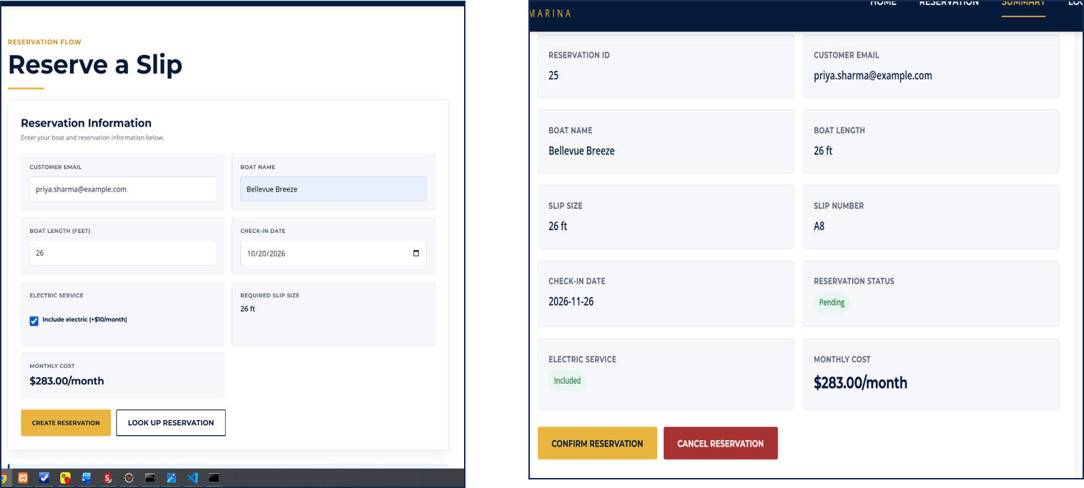

Test 4 | Confirming a Pending Reservation from the Summary Page
 | Test Objective: Verifies that using the summary page's confirm action updates both the reservation's status and the assigned slip's status correctly, and that the change is reflected immediately on the page. | Developer: Aftabur Rahman  Date tested: <2026/09/12> | Peer tester: MaxJankowski  Date tested: <2026/09/12>
Step | Action | Expected results: | Developer pass/fail | Tester pass/fail
1 | Open reservation-summary.html for a reservation whose Status currently shows "Pending." | The page loads with a visible option to confirm the reservation. | yes | yes
2 | Click the button or link to confirm the reservation. | The request succeeds and the page updates without a full reload or error. | Yes | yes
3 | Review the Status field after confirming. | It now displays "Confirmed" instead of "Pending." | yes | Yes
4 | Check the slips table for the slip assigned to this reservation (via the mysql shell). | That slip's status has changed from HELD to RESERVED. | Yes | yes
5 | Refresh the summary page. | The reservation still shows "Confirmed," confirming the change was saved to the database rather than only updated on screen temporarily. | yes | yes
Comments | Some minor changes need to be made to the RevervationDAO and servlet to make sure that the db and server were communicating properly. See the pending status above.

